**PRACTICAL – 7(7.1)**

**AIM:**

**Write a program that asks the user how many Fibonacci numbers to generate and then generates them. Take 2 1,2 this opportunity to think about how you can use functions. Make sure to ask the user to enter the number of**

**numbers in the sequence to generate. (Hint: The Fibonacci sequence is a sequence of numbers where the next**

**number in the sequence is the sum of the previous two numbers in the sequence. The sequence looks like this: 1,**

**1, 2, 3, 5, 8, 13, ...)**

**PROGRAM:**

|  |
| --- |
| **def FibonacciNum(n):**  **n1 = 0**  **n2 = 1**  **if (n < 1):**  **return**  **print(n1, end=" ")**  **for i in range(1, n):**  **print(n2, end=" ")**  **sum = n1 + n2**  **n1 = n2**  **n2 = sum**  **FibonacciNum(int(input("Enter the range: ")))**  **print("\n\n20DCE019 - Yatharth Chauhan")** |

**OUTPUT:**

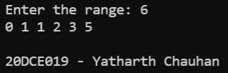

**CONCLUSION:** In this practical we learned about the usage of functions.

**PRACTICAL – 7(7.2)**

**AIM: Write a program (function!) that takes a list and returns a new list that contains all the elements of the first 1,2 list minus all the duplicates.**

**PROGRAM:**

|  |
| --- |
| **def dedupe_v1(x):**  **y = []**  **for i in x:**  **if i not in y:**  **y.append(i)**  **return y**  **a = [2, 3, 3, 2, 5, 6, 7, 8, 5, 6]**  **print("Original list", a)**  **print("Duplicate list", dedupe_v1(a))**  **print("\n20DCE019 - Yatharth Chauhan")** |

**OUTPUT:**

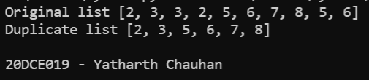

**CONCLUSION:** In this practical we learned about the use of def keyword.